Valley of Pensacola Executive Committee

Summary of the Meeting

June 6, 2019

The Executive meeting was called to order with the Pledge to the Flag lead by Hon. Kenneth Eichorn, 32°, KCCH.

The Invocation was given by: Hon. Joel Fairbanks, , 32°, KCCH.

**Executive Committee Members:**

Kurt Larson, 33˚, P.R. to Deputy, PRESENT

James A. Salisbury, 32°, KCCH, General Secretary, PRESENT

Roger White, 33°, Treasurer, Present

Kenneth K. Eichorn, 32°, KCCH, Master of Kadosh, PRESENT

Herman M. Davies, 32°, KCCH, Consistory Prior, ABSENT

Kevin D. Riley, 32°, KSA, Wise Master, Pensacola Chapter of Rose Croix, PRESENT

Oscar G. Laurene, 32°, KSA, Venerable Master, Pensacola Lodge of Perfection, PRESENT

William E. Waters, 32°, Commander, Council of Kadosh, PRESENT

Jimmie Lindt, 33°, Bldg. Association Member at Large, PRESENT

William Bonifay, 33°, Building and Grounds, PRESENT

Joel K. Fairbanks, 32°, KCCH, Member at Large, PRESENT

Guest: NONE

**Calendar of S.R. Near Events**:

**June 1** York Rite Ladies 10:00 AM

Pensacola 42 Stated Communication 5:00 PM

**June 5** Education and Sandwich Supper 5:30 PM

**June 6** Executive Meeting 4:30 PM

KCCH Meeting – Conference Room 5:30 PM

KSA Meeting – Library 5:30 PM

Invocation followed by Dinner 6:15 PM

Program – Feast of the Consistory, BBQ Kick-Off,

Sitting Masters

KCCH Color Guard

Host Master of Kadosh, Consistory

New letters are Due

**June 13** BBQ Sale Prep Day

**June 14** Flag Day Program 12 PM

**June 14** BBQ Sandwich Sale 11-1:30 PM

**June 15** BBQ Sandwich Sale Car City 11-1:30 PM

**June 18** Newsletter Production 9:00 AM

Fellowship Luncheon 12:00 PM

**July 4** **No Meetings – Independence Day**

**Building Usage Report:** During the preceding month the building was utilized as indicated

May 1st Education and Sandwich Supper

May 6th York Rite Ladies

Pensacola 42 Stated Communication

May 13th York Rite Stated Communication

May 20th Pensacola 42 Stated Communication

May 22nd York Rite Commandry Practice

York Rite Executive Committee Meeting

May 30th Knights of Saint Andrew (cancelled)

May 31st AMD (cancelled)

During the month of May $247.00 was collected for the Scottish Rite Foundation of Florida, Inc. Additionally, the Almoner fund is getting low. We need to consider supplementing funds for this endeavor.

**Treasurer’s Report**:

* Ill. White’s Treasurer’s Report was presented**. Motion Made to accept by**: Hon. Joel Fairbanks, , 32°, KCCH. **Seconded by:** Bro. Kevin Riley, 32°, KSA. **PASSED**

**Secretary’s Report:**

* Calendar available online at PensacolaScottishRite.org.

**Personal Representatives Report:**

* Gave a report on the results of the Valley Survey just completed. Explained that these are still just very raw information.

**Correspondence**: **None**

**Old Business:**

* Master of Kadosh reminded all about the upcoming BBQ Sandwich Sale/Fund Raiser for the Foundation. June 13th, will be prep date, June 14th and 15th will be days of sales.

**New Business**:

* Americanism Update; Friday June 14th at 12PM the Valley will observe Flay Day.
* Hon. Joel Fairbanks gave a update on VMAP.

**Charity of the Month:** Scottish Rite Foundation of Florida.

There being no further business the meeting was adjourned at 5:24 P.M.

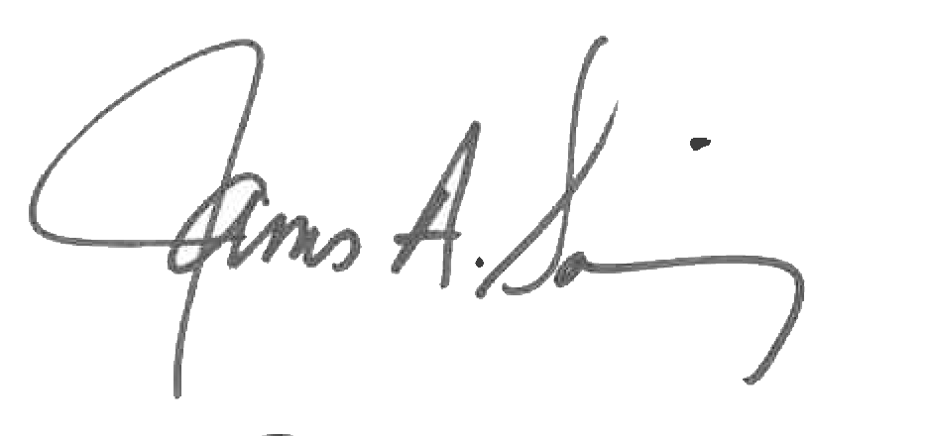 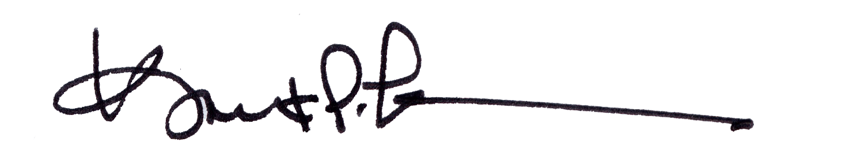

James A. Salisbury, 32°, KCCH Kurt Larson, 33°

General Secretary Personal Representative